**Domain : Exam Suite**

**Front-end: Java (JDK 1.5, JDK 1.6, and JDK 1.7)**

**Back-end : MS Access 2003**

Before you compile the project you have to set the **ODBC connection** then only it will work properly

Let us see **How to set ODBC connection (MS Access)**

1. Click **Start** button +Click **Settings**

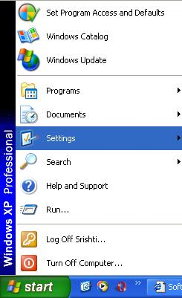

1. Click **Control Panel**

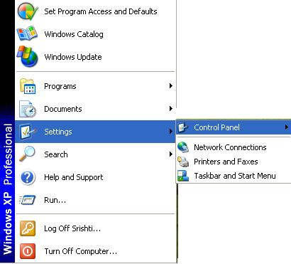

1. Select **Administrative tools** + **Click data Sources (ODBC**)

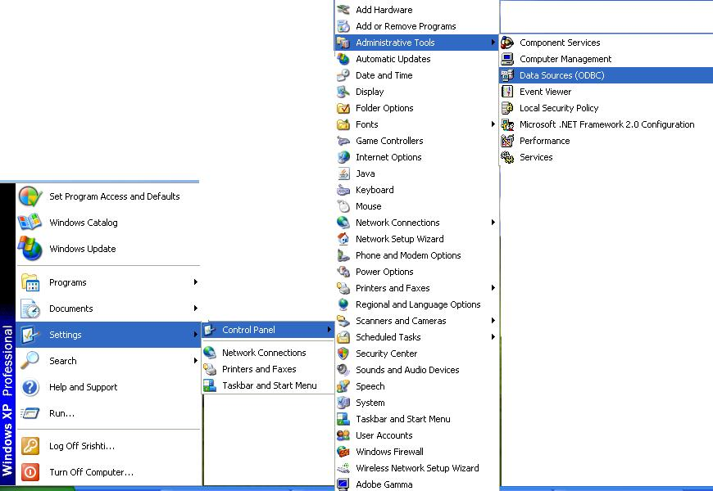

4. Then you get ‘ODBC **Data Source Administrator**’ window (shown below) +Click **Add** Button

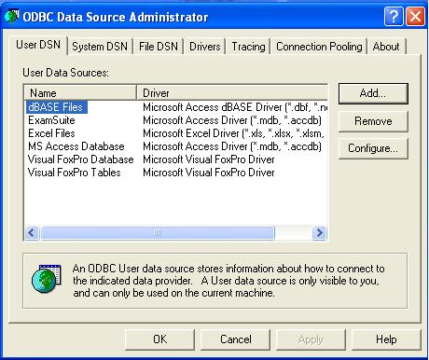

5. Create **New Data Source** (shown below) +select **Microsoft Access Driver (*.mdb,*.accdb)** + press **Finish** button

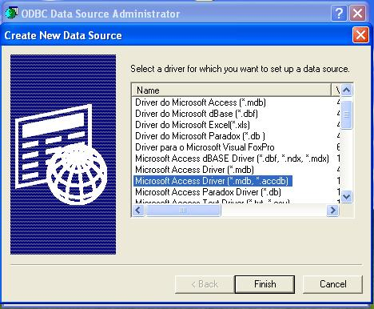

6. ODBC Microsoft Access Set up (shown below) + gives **Data Source Name**

+select **Database (Press select button**) +select your database (shown below) + Press **Ok** button

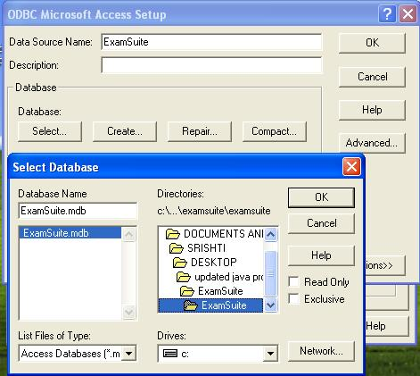

7. Before you close the window make sure that your DSN name is correct or not (shown below) +Press **Ok** button

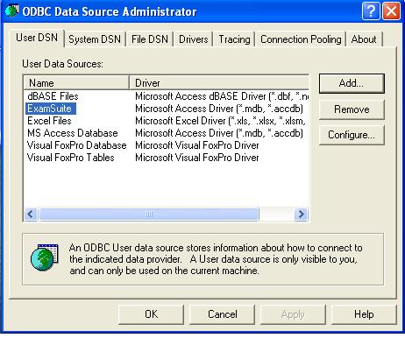

Now you got the DSN name (ExamSuite)This is the way for connecting ODBC, if you have any doubt please mail us .